**Tasks**

1. What is miniconda and what is the difference between it and Anaconda?

**Anaconda** and **miniconda** are software distributions that are widely used in data science to simplify package management and deployment.

## Differences

There are essentially two main differences:

1. **Number of packages:** Anaconda comes with over 150 data science packages, whereas miniconda comes with only a handful.
2. **Interface:** Anaconda has a graphical user interface (GUI) called the Navigator, while miniconda has a command-line interface.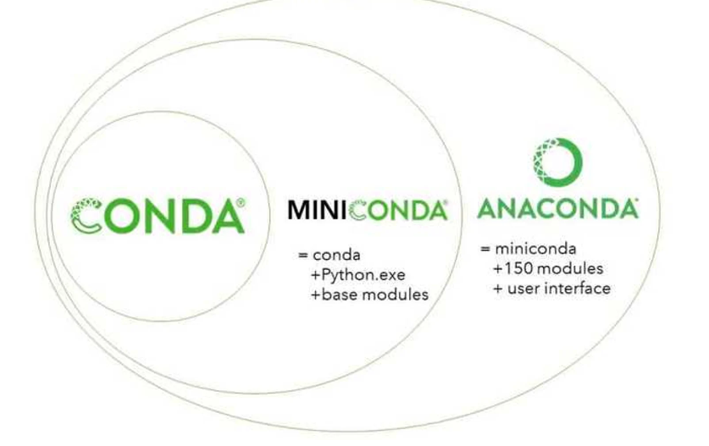

## How to choose

Choose Anaconda if you:

* Are new to conda or Python
* Like the convenience of having Python and over 150 scientific packages automatically installed at once
* Have the time and disk space (a few minutes and 3 GB)
* Don’t want to have to individually install each of the packages you want to use

Choose miniconda if you:

* Do not mind individually installing each of the packages you want to use
* Do not have time or disk space to install over 150 packages at once
* Want fast access to Python and the conda commands and wish to sort out the other programs later.

## What is frameworks? Why do we use frameworks? adv and dis ?

A framework is a structure that you can build software on. It serves as a foundation, so you're not starting entirely from scratch. Frameworks are typically associated with a specific programming language and are suited to different types of tasks.

Let's say you're building a house. You could pour the foundation and frame the house yourself. It would take a lot of time, but you could do it. If all of that were already done for you, though, it would save you quite a bit of effort — especially if it was done by expert home builders.

A house isn't complete with just the framework, though. Similarly, a framework in software development is a starting point, but you add higher-level functionality to it to make it work.

Using frameworks saves time and reduces the risk of errors. You don't need to write everything from the ground up, so there's less chance of introducing errors. Plus, frameworks have already been tested, so there's less to worry about.

Other advantages include:

* More secure code
* Simpler testing and debugging
* Avoiding duplicate code
* Clean and easily adaptable code
* Able to focus on writing code specific to the project
* Can be extended

## Types of frameworks

Frameworks can be used for developing websites, mobile applications, data science, and more. Here are some of the more popular frameworks:

**AngularJS** is a front-end JavaScript framework. It's one of the most popular web frameworks and is backed by an enthusiastic community.

[**Django**](https://www.codecademy.com/learn/paths/build-python-web-apps-with-django?utm_source=ccblog&utm_medium=ccblog&utm_campaign=ccblog&utm_content=cw_what_is_a_framework_blog) is an open-source web development framework supported by the Django Software Foundation. It's written in [Python](https://www.codecademy.com/catalog/language/python?utm_source=ccblog&utm_medium=ccblog&utm_campaign=ccblog&utm_content=cw_what_is_a_framework_blog), a popular programming language, and is designed to encourage "[rapid development](https://www.djangoproject.com/) and clean, pragmatic design." It's fast, secure, and scalable.

### **Mobile development frameworks**

[**Flutter**](https://flutter.dev/) is Google's open-source framework. It supports iOS and Android and has fully customizable widgets.

Flutter is designed to speed up app development and create attractive, user-friendly apps. It uses a thin layer of [C](https://www.codecademy.com/resources/docs/c?utm_source=ccblog&utm_medium=ccblog&utm_campaign=ccblog&utm_content=cw_what_is_a_framework_blog)/[C++](https://www.codecademy.com/catalog/language/c-plus-plus?utm_source=ccblog&utm_medium=ccblog&utm_campaign=ccblog&utm_content=cw_what_is_a_framework_blog) code, but most of its system is in Dart.

[**React Native**](https://www.codecademy.com/learn/learn-react-native?utm_source=ccblog&utm_medium=ccblog&utm_campaign=ccblog&utm_content=cw_what_is_a_framework_blog) was developed by Facebook. It's open-source, cross-platform, and written in JavaScript. It's used in many popular apps, including Discord, Instagram, and Shopify.

[**Ionic**](https://ionicframework.com/) is another open-source, cross-platform framework. It uses JavaScript, [HTML, and CSS](https://www.codecademy.com/catalog/language/html-css?utm_source=ccblog&utm_medium=ccblog&utm_campaign=ccblog&utm_content=cw_what_is_a_framework_blog), and it includes a library of mobile-optimized UI components, gestures, and tools. Ionic builds fast apps and integrates with front-end frameworks like Angular and Vue.

Most popular 5 processors in laptops and 5 in mobiles ?

In laptops:

1-intel core i7-12700H , base/max cpu:1.70-4.70 GHZ

2-intel core i9=12900H,1.80-5.00 GHZ

3-intel core i7-12800H,1.80-4.80 GHZ

4-AMD ryzen 7 6800H,3.20-4.70 GHZ

5-intel core I5-12500H,1.80-4.50 GHZ

In mobiles

1-Apple A15 Bionic , iphone 13,clock:3240mhz

2-Dimensity 9000 , vivo x80,3200mhz

3-Snapdragon 8 Gen 1, OnePlus 10 Pro,3200mhz

4-Apple A14 Bionic, Apple iPhone 12,3050mhz

5-Snapdragon 888 Plus, Asus ROG Phone 5S,3000mhz

What is hash table ? why use it in unorderdlist?

Hash tables are used to implement map and set data structures in most common programming languages. In C++ and Java they are part of the standard libraries, while Python and Go have built-in dictionaries and maps.

A hash table is an **unordered** collection of **key-value** pairs, where each key is **unique**.

Hash tables offer a combination of efficient **lookup**, **insert** and **delete** operations

## **Hashing with chaining**

The most common hash table implementation uses chaining with linked lists to resolve collisions. This combines the best properties of arrays and linked lists.

Hash table operations are performed in two steps:

* A key is converted into an integer index by using a hash function.
* This index decides the linked list where the key-value pair record belongs.

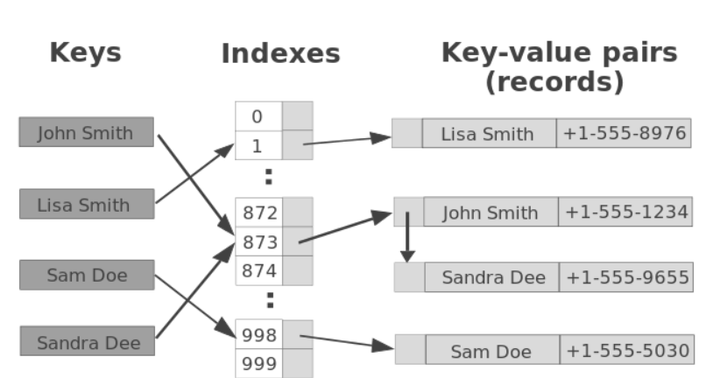

How I do print an exception in python?

For ex:

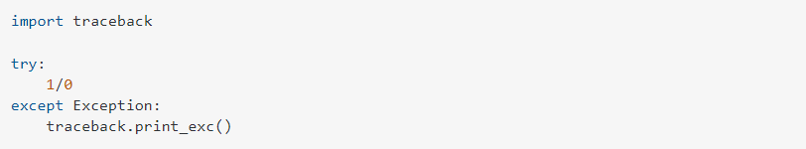

Output:

